**Preferred Positions for Play**

**Encourage children to use a variety of different positions for play:**

* Develops strength, stability and balance control in the trunk muscles
* Encourages lots of free movement in and out of positions, allowing children to play with toys around them
* Positions of weight bearing through the arms develops muscle strength in hands and shoulders

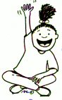 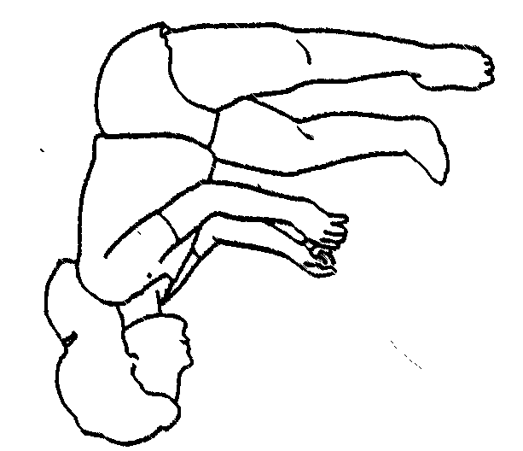 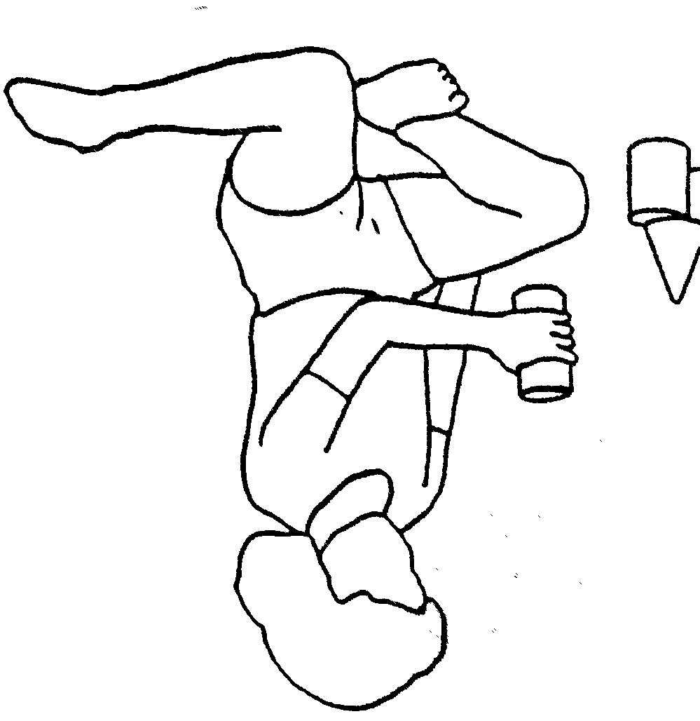 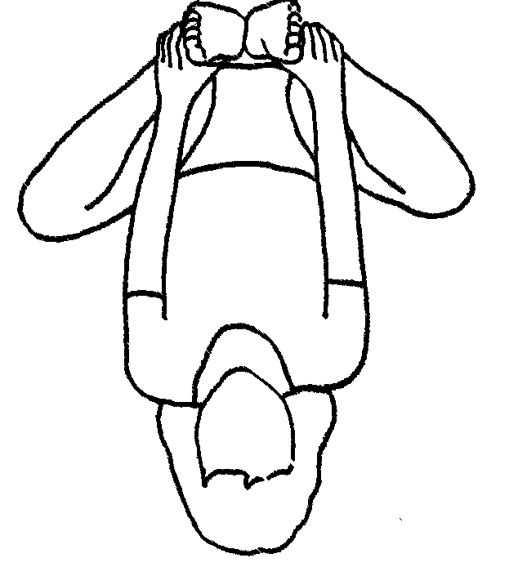

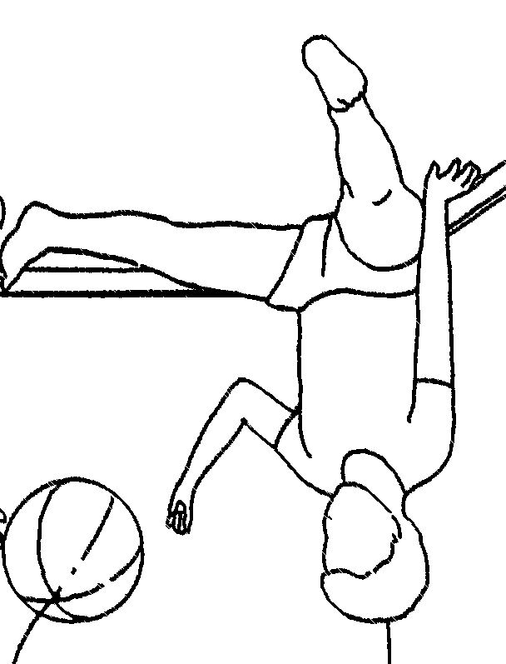 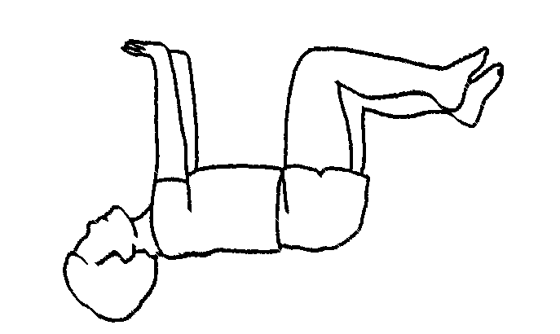 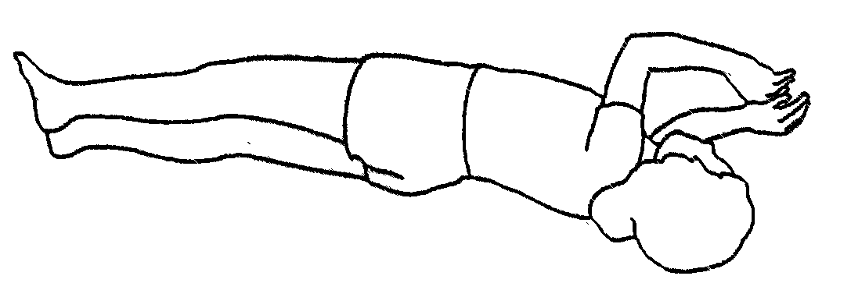

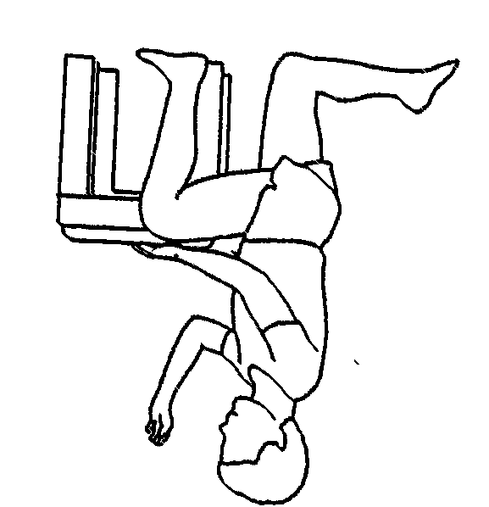 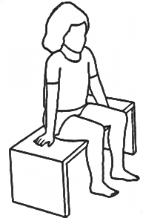 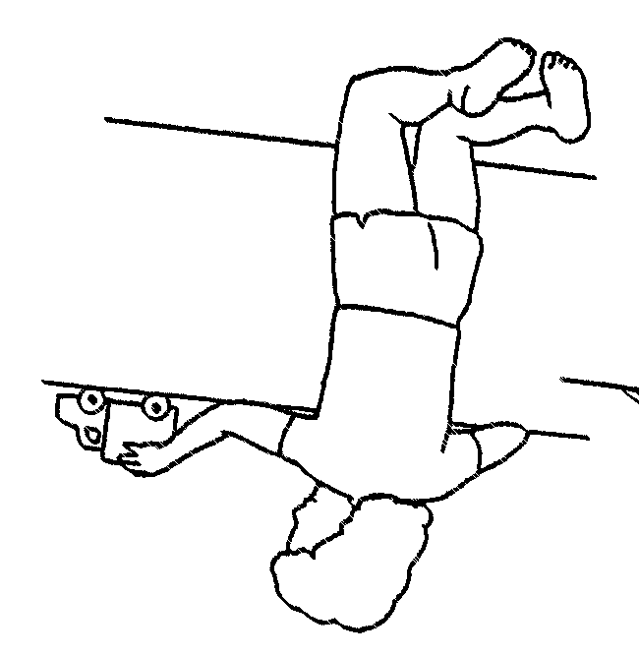 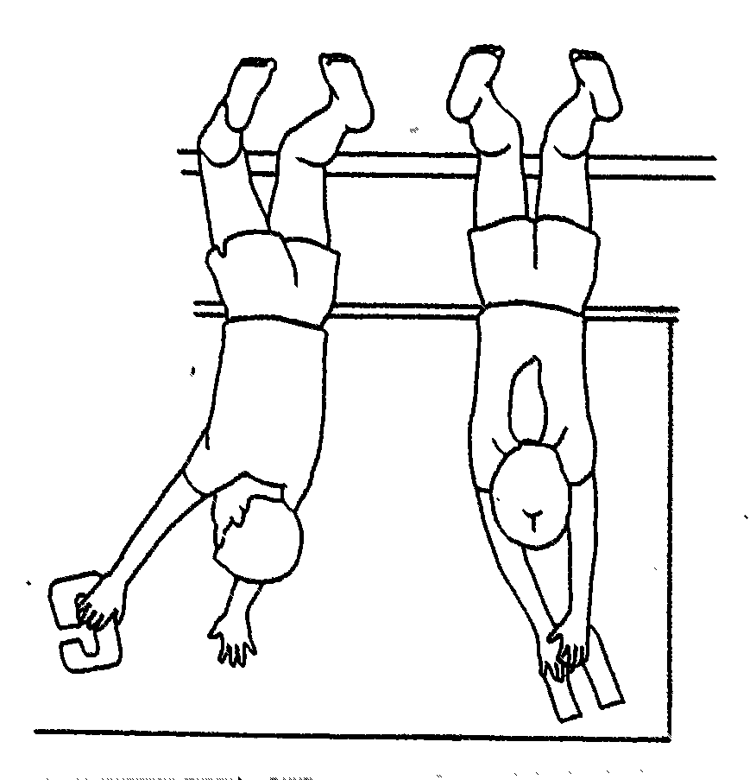

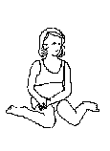 s

**What is wrong with W-sitting?**

* Does not engage core muscles of the trunk to develop balance and strength
* Inhibits trunk rotation and crossing the midline and may delay hand dominance
* Does not allow child to move freely in and out of positions thereby confining play to midline
* Long term it may cause muscle tightness, strain on knee and hip joints